**EFFICIENT DATA RETRIEVAL**

**A SUMMER INTERNSHIP REPORT**

***Submitted by***

PONKIYA HEPIN RAMJIBHAI

200410116021

***In Partial fulfillment for the award of the degree Of***

**BACHELOR OF ENGINEERING**

***in***

**Information Technology**

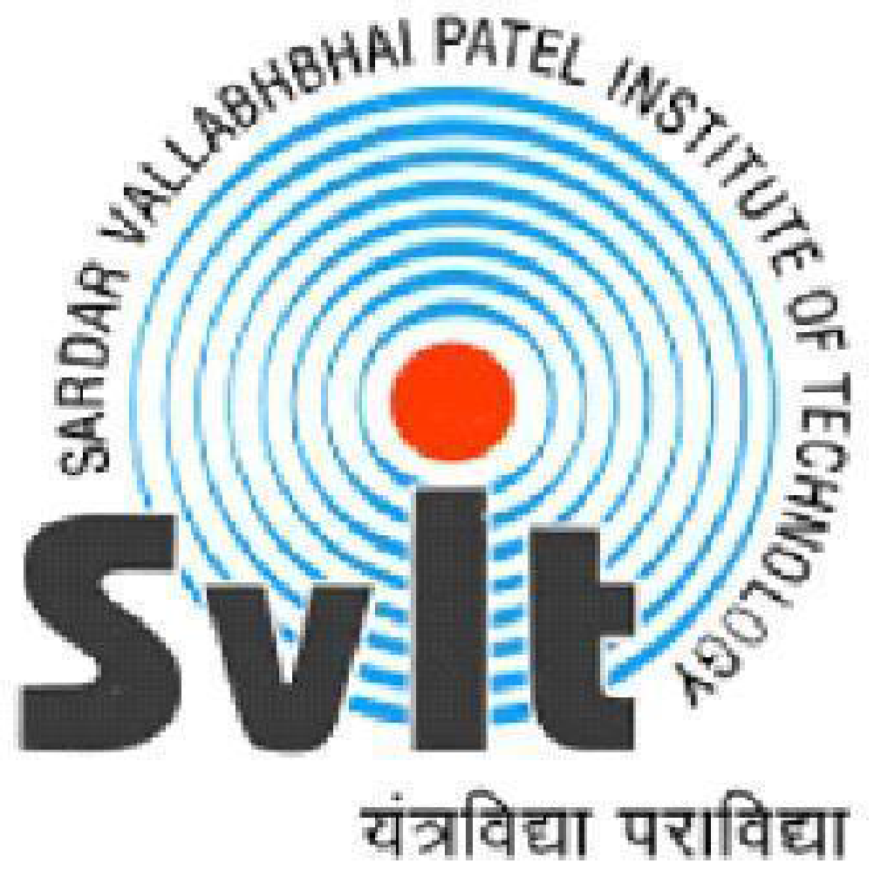

Sardar Vallabhbhai Patel Institute of Technology, VASAD.

**Gujarat Technological University, Ahmedabad**

**August, 2023**

**SARDAR VALLABHBHAI PATEL INSTITUTE OF TECHNOLOGY, VASAD.**

INFORMATION TECHNOLOGY ENGINEERING

2023-24



**CERTIFICATE**

**Date: ___/___/2023**

This is to certify that the Summer Internship Work entitled “EFFICIENT DATA RETRIEVAL” has been carried out by PONKIYA HEPIN RAMJIBHAI (200410116021) under my guidance in fulfillment of the degree of Bachelor of Engineering in Information Technology (7th Semester) of Gujarat Technological University, Ahmedabad during the academic year 2022-23.

Internal Guide Head of the Department

Prof.(Parita Parikh) Dr. B.J.Talati

Asst. Prof. IT Dept.

SVIT,VASAD SVIT,VASAD